
12 ATAR Physics

Electromagnetism Investigation

Part 2 - Quiz Mark: $\frac{}{\text{50}}$

Name:

You should have your research section of the investigation with you.

1. State what the betatron is mainly used for. [3 marks]

2. What is the value of the speed mentioned as v = 0.999987c where c is the speed of light? Give your answer to 5 significant figures. [2 marks]

3. Show that 1.0 Volt = 1.0 Weber/second. [3 marks]

4. Explain why an electron-volt can be considered to be a unit of energy. [2 marks]

5. Can an induced current ever establish a magnetic field B that is in the same direction as the magnetic field inducing the current? Justify your answer. [3 marks]

6. Suggest a suitable material for the magnetic core of the betatron. Justify your answer. [2 marks]

7. In the betatron, the magnetic core is made of laminated sheets rather than of solid material. Explain why this is so. [3 marks]

8 (a) Explain how the magnetic field guides the electrons in a circular path.
[2 marks]

(b) Explain how the changing magnetic field produces an induced electric field in the electron chamber. [2 marks]

9. You want to increase the radius of the circular path by imposing an additional magnetic flux $∆Φ$. Should the lines of B associated with this increase be in the same direction as the lines shown in the figure or in the opposite direction? Explain your answer. [3 marks]

10. (a) State the direction of the force acting on the electron on the right-hand side of the betatron (See Fig. 1 of the research handout). [1 mark]

(b) Explain how you arrived at your answer. [2 marks]

11. In a 100 MeV betatron, the orbit radius R is 84.0 cm. Assume that the orbit is circular. The magnetic field in the region enclosed by the orbit rises periodically (60 times per second) from zero to a maximum value $B_{max}=0.800\text{T}$ in an accelerating interval of one-fourth of a period, or 4.20 ms.

(a) What is the maximum magnetic flux, $Φ_{max}$ , attained during the accelerating interval? [2 marks]

(b) Using the answer to (a), determine the rate of change of flux (induced EMF) during the time interval of acceleration. [2 marks]

(c) Given that 1.00 eV (electron volt) is the energy gained by an electron moving across a potential difference of 1.00 V, show that the number of revolutions required for an electron to reach its final energy of 100 MeV is approximately 238,000 revolutions. [2 marks]

(d) Find the total distance travelled by an electron along its circular path before reaching its full energy of 100 MeV. [2 marks]

(e) Calculate the average speed of the electron as it travels the total distance needed to reach 100 MeV during the acceleration time interval of 4.20 ms. [2 marks]

12. The varying magnetic field in the betatron can be represented by the graph below.
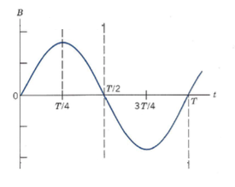

On the axis below, sketch the shape of a corresponding graph of induced EMF versus time as the B field varies. [3 marks]
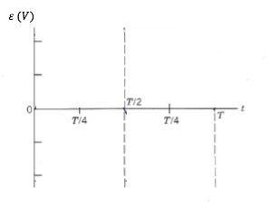

13. Once accelerated, the electrons are directed out of the doughnut chamber, or inwards, towards a metal target to produce x-rays. X-rays are a form of electromagnetic radiation. They have a wavelength ranging from 0.0100 to 10.0 nm.
What are the highest and lowest frequencies of x-rays? [3 marks]

14. The betatron can be thought of as a transformer. Transformers have a primary and secondary coil. The magnetic field is changed by passing alternating current to the primary coil. A current is induced in the secondary coil by Faraday’s Law. [2 marks]

(a) State which part of the betatron behaves like the primary coil of a transformer.
(See Fig. 1 of the research handout.)

(b) State which part of the betatron behaves like the secondary coil of a transformer.

15. Referring to the values given in Question 11, suggest TWO strengths of the design of a betatron as a particle accelerator. [2 marks]

16. Describe TWO ways that you can increase the energy of radiation emitted by the betatron? [2 marks]

END OF TEST

